 Line of Business: Typelists

Investigation Exercise

Answer the following questions about the line of business model in the base application.

1. Which loss type has the largest number of LOB codes?

2. Which policy type belongs to more than one LOB code? What codes does it belong to?

3. Which policy type is retired?

4. Are any coverages shared by both the General Liability and Professional Liability policies?

5. Compare these two coverages: "Farmowners" and "Earthquake". Do they both map to the same number of exposure types? Do they map to the same exposure type?

6. View the General Liability coverage. It maps to nine coverage subtypes, but it maps to only four exposure types. Why do you think this coverage maps to a multiple exposure type in more than one way?

Configuration Exercise

Configure ClaimCenter to meet the following customer requirement from Acme Insurance.

Requirement 1: Earthquake Coverage Does Not Map to Content Exposure Type

In the base application, the Homeowner's Earthquake coverage (code HODW_Earthquake_HOE) maps to three exposure types: Dwelling, Other Structure, and Content. However, the ACME claims process for this coverage does not require the capturing of information for Content Damage, and they want their Earthquake coverage to map only to the the Dwelling and Other Structure exposure types. In other words, they will not offer Content as part of their Earthquake coverage.
.

7. Modify the Earthquake coverage so that it no longer allows the option to create a "Content" exposure type. There are three options for making this change. Consider which would be the best choice.
Remember that all data model changes, including changes to the LOB, require a server restart.

Test Cases: Requirement 1

When you have completed your configuration, run the following test cases:

8. Navigate to a claim for a Homeowner's policy (such as claim 426-24-366170). (You can log in as William Dufraine – wdufraine/gw.) Verify that you can create an exposure tied to Earthquake coverage, but none of the options lead to a screen labeled "New Exposure - Content".

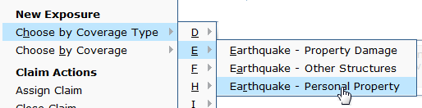


Requirement 2: New Erosion Coverage

Acme Insurance offers Erosion coverage with its policies. It covers losses to homes due to erosion. However, there is no such coverage in ClaimCenter's line of business model in the base application.

Note: There is an issue with the H2 database that we use for training. It cannot handle the number of database updates that the LOB modifications in this requirement will trigger. Because of that, we are supplying a workaround, which will be highlighted in yellow in these instructions.

9. Modify the line of business model so that an adjuster working on a claim tied to a homeowner's policy can create an exposure associated to Erosion coverage. For the time being, you can map the coverage to the Property exposure type. (The internal code for the Erosion coverage should be "ERO".)

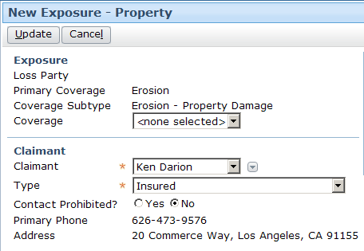

Go to C:\Guidewire\ClaimCenter. Rename your db directory to something like dbXXX. This has the effect of preserving your data if you have any need for it later, but effectively dropping your database as far as ClaimCenter and H2 are concerned.

Test Cases: Requirement 2

Go to C:\Guidewire\ClaimCenter and restart ClaimCenter. Server startup might take a little longer since ClaimCenter is building the database from scratch.

Once ClaimCenter is ready, log in as su/gw. In ClaimCenter, key in <Alt><Shift>-T. This will take you to the Tools page. Click on the Internal Tools tab. Go to the CC Sample Data link. Load the Demo sample data. This will import admin and claim data for you to continue testing. Once loaded, log out of ClaimCenter and begin testing, as described below.

When you have completed your configuration, run the following test cases:

10. Navigate to a claim for a Homeowner's policy (such as 426-24-300170). Create an erosion exposure.
If for some reason your new Coverage did not work as planned, and you need to make further edits to the LOB typelists, you will need to delete the db directory again (do not rename and save it), and reload the sample data again after server restart.

You should not have to use this workaround for requirements 2a or 3 in this lab.

Requirement 2A: Completing the Erosion Coverage

At this point, you should be able to create exposures using the erosion coverage and reserve lines for these exposures. But, Acme Insurance users need certain information connected to all exposures and coverage types.

Each new exposure must have a stated Loss Party. For the erosion coverage, this should be "Insured's loss".

Old look:
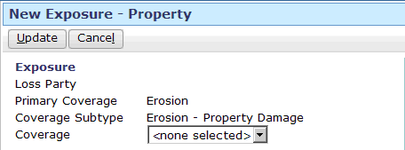

When a reserve line is created using the Erosion coverage, if the cost type is Claim Cost, then the following options should appear for cost categories: Labor, Mileage reimbursement, Other, Unspecified Cost Category.

Old look:
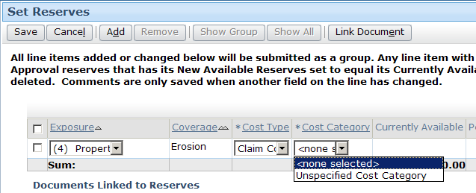

11. Modify ClaimCenter so that:
- Exposures mapped to the Erosion coverage have a loss party of "Insured's loss".
- For reserve lines mapped to erosion exposures, a reserve line with cost type "Claim Cost" can have a cost category of "Labor", "Mileage reimbursement", "Other", "Unspecified Cost Category".

12. The ClaimCenter implementation team has provided additional notes:
- This requirement should be implemented solely through typelist modification. Do not write any GScript rules or functions to enforce this.
- Use the data dictionary to locate the data model fields for Exposure's Loss Party and the Reserve's Cost Category to determine what are the current possible values

Test Cases: Requirement 2A

When you have completed your configuration, run the following test cases:

13. Navigate to a claim for a Homeowner's policy (such as 426-24-366170). Create an erosion exposure. Verify that the loss party field is set to "Insured's loss".

New look:
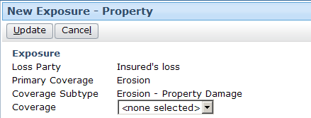

14. Create a reserve line for the exposure. Verify that there are now four options for cost category when cost type is "Claim Cost".

New look:
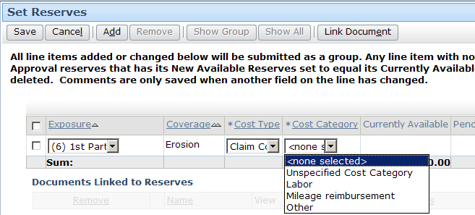

Requirement 3: Removing the "Extra Expenses" Coverage

Base ClaimCenter comes with an “Extra Expenses” coverage that is available on two policy types – Commercial Property and Commercial Package. Acme Insurance does not sell "Extra Expenses" coverage on their Commercial Property policies. During initial user acceptance, the implementation team does not want test users to be able to create "Extra Expenses" exposures, as they feel it will be a source of confusion for them. However, the acceptance testing will focus on new claim creation, so they are not concerned about any policies in the test data with Extra Expenses coverage.

15. Modify the line of business model so that Acme Insurance users can not create exposures pertaining to the Extra Expenses coverage on Commercial Property policies, but they can still create them on Commercial Package policies.

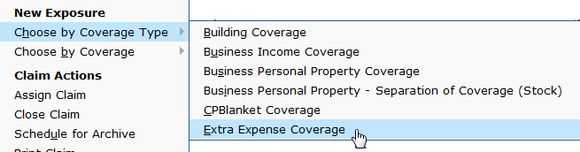

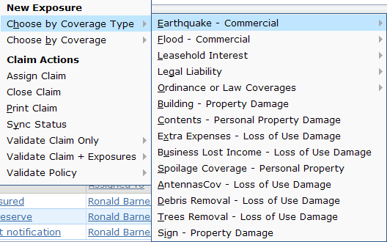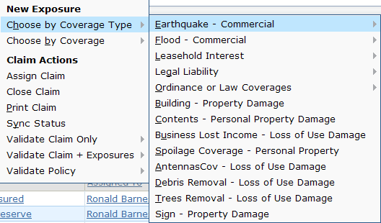

16. The ClaimCenter implementation team has provided additional notes:
- Do not retire or delete the Extra Expenses coverage, because it is still required for Commercial Package policies.
- Do not retire or delete the Loss of Use Damage Exposure as this is used by other coverages which are not being eliminated, such as Business Lost Income and Trees Removal.
- HINT: Examine the Commercial Property policy type's Extra Expenses coverage and notice that it has multiple parents. Consider removing it from this parent.

Test Cases: Requirement 3

When you have completed your configuration, run the following test cases:

17. Navigate to a claim 426-24-366071, which is a Commercial Property claim related to a policy with Extra Expenses coverage. Verify that you can view the Extra Expenses coverage on the Policy : Locations screen, for risk #1.

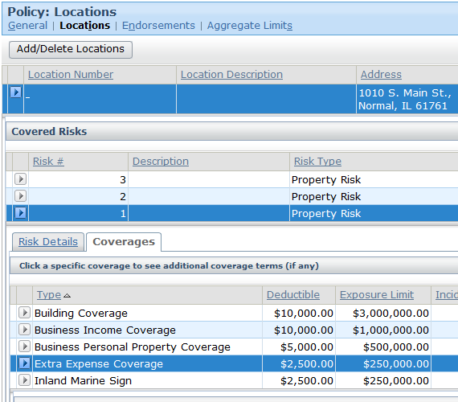

18. On the same claim, verify that you cannot create an exposure (through the “Choose by Coverage Type” menu) which uses the LOB definition to determine available exposures.

